CHAPTER 3
STYLES
This chapter discusses what a style is, how it is applied, and how it should be used to create your thesis or dissertation.

What Is a Style?
Styles define the appearance of various text elements of your document, such as headings, captions, and body text. When you apply a style to a paragraph or word, you can apply a whole group of character or paragraph formats or both in one simple operation. When you want to change the formatting of all the text of a particular element at once, you just change the style that's applied to that element. Styles make formatting your document easier. Additionally, they serve as building blocks for outlines and tables of contents.
At CIRCA we created a group of general purpose styles to help you format your document and give your thesis or dissertation a continuity of appearance. Styles cannot do everything but they can be used for general formatting purposes. Each style created by CIRCA is listed in Table 3-2.
Alternative styles for first-level, second-level, and third-level subheadings are included in Table 3-2. They are denoted by the letter "B" at the end of the style name. You should decide on which set of subheading styles you prefer. Mixing the subheading styles is not permissible.
Table 3-1. List of styles used throughout the Master Document
Styles | Apply to | What you must do after the style is applied
Body Text | Paragraphs | Nothing
Block Text | Quotes | Nothing
Body Text No Indent | Paragraphs where indenting is not permitted | Nothing
One Inch Spacer | This style is applied to the first line of any Chapter or Section | Nothing
CHAPTER TITLE | Chapter and Section titles | Capitalize all letters.
Heading 1 | First-Level Subheadings | Capitalize first letters of principal words
Heading 2 | Second-Level Subheadings | Capitalize first letters of principal words
Heading 3 | Third-level subheadings | Capitalize the first letters of first word and all proper nouns
Heading 1B | First-Level Subheadings | Capitalize first letters of principal words
Heading 2B | Second-Level Subheadings | Capitalize first letters of principal words
Heading 3B | Third-level subheadings | Capitalize the first letters of first word and all proper nouns
Normal | Used inside tables and on single spaced text | Nothing
Caption: Table | Table captions | Nothing
Caption: Figure | Figure captions | Nothing

The One Inch Spacer style is used for numbering chapters. The paragraph heading style was not included. The paragraph style is the bolding or underlining of the first words of a paragraph. Most paragraphs should use the Body Text style for formatting.

How Do You Apply a Style?
The styles used in this document are called paragraph styles. Paragraph styles are used to format the entire text within a paragraph. Styles can be applied manually or automatically. To apply a style manually, follow these instructions:
• Place the cursor into the text you want to format.
• Click the Format menu and then the Style option.
• Double-click the style in the Styles list. The text is now formatted by the specifications of the style. If, at any time, the text should appear wrong, simply reapply the style.
An alternative way of selecting the style is to use the Formatting toolbar:
• Place the cursor into the text you want to format.
• Click the Down-Arrow next to the Style field on the Format toolbar and select a Style from the drop-down list.
If the Formatting toolbar is not present, click the View menu and then the Toolbars option. In the Toolbars list, check Formatting and click the OK button. The Formatting toolbar should appear at the top of your screen.
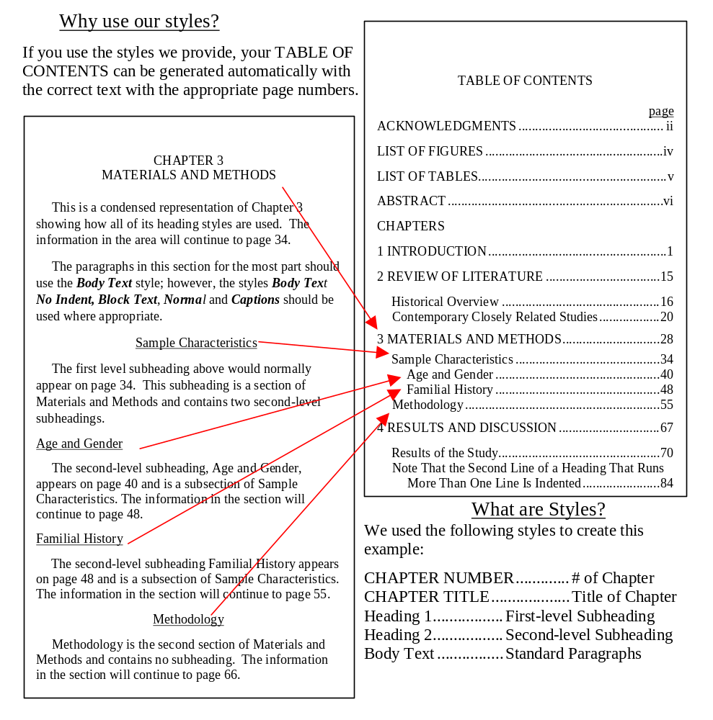
Figure 3-1. How styles appear in the table of contents

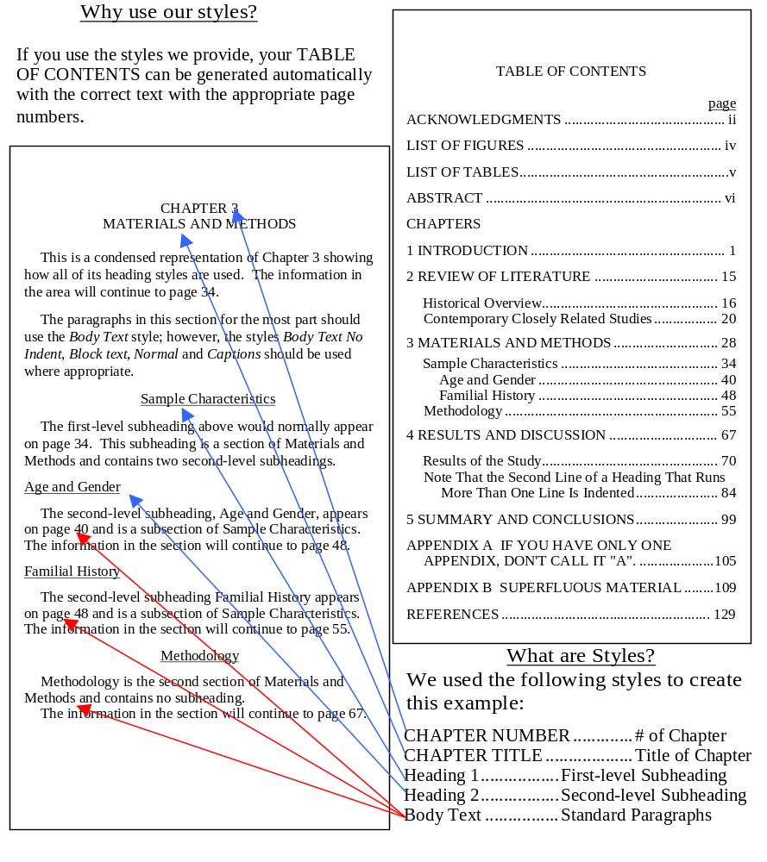
Figure 3-2. What styles are being used

Microsoft Word 98, Help text, Microsoft Corporation

